Experiment: K-Nearest Neighbors (KNN) for Classification

Aim:
- To implement the K-Nearest Neighbors (KNN) algorithm for classification.
- To evaluate model performance using confusion matrix and accuracy metrics.
- To analyze how the value of K (number of neighbors) affects performance.
Theory:
What is KNN?
- KNN is a supervised learning algorithm used for classification and regression.
- It is a lazy learning algorithm (no training phase).

How KNN Works:
- Choose a value of K
- Calculate distance between new point and all training data
- Select K nearest neighbors
- Assign class based on majority voting

Distance Formula (Euclidean):
$$d=\sqrt{\left(x_{2}-x_{1})^{2}+(y_{2}-y_{1})^{2}\right.}$$

Key Points:
- Small K → overfitting
- Large K → underfitting
- Works best with normalized data

Procedure:
- Load dataset using pandas
- Separate features (X) and target (y)
- Convert categorical labels to numeric
- Split dataset into training and testing sets
- Normalize data (important for KNN)
- Train KNN model with chosen K value
- Make predictions
- Evaluate using:
  - Confusion Matrix
  - Accuracy Score
- Compare accuracy for different K values

FULL CODE (Single Script)
# K-NEAREST NEIGHBORS (KNN) CLASSIFICATION
import pandas as pd
from sklearn.model_selection import train_test_split
from sklearn.preprocessing import StandardScaler
from sklearn.neighbors import KNeighborsClassifier
from sklearn.metrics import confusion_matrix, accuracy_score
# -------- LOAD DATASET --------
data = pd.read_csv("iris.csv")
print("Dataset Preview:")
print(data.head())
# -------- FEATURES & TARGET --------
X = data.drop("species", axis=1)
y = data["species"]
# Convert categorical labels to numeric
from sklearn.preprocessing import LabelEncoder
le = LabelEncoder()
y = le.fit_transform(y)
# -------- TRAIN TEST SPLIT --------
X_train, X_test, y_train, y_test = train_test_split(
X, y, test_size=0.2, random_state=42
)
# -------- FEATURE SCALING --------
scaler = StandardScaler()
X_train = scaler.fit_transform(X_train)
X_test = scaler.transform(X_test)
# ====================================================
# KNN MODEL
# ====================================================
k = 5
knn_model = KNeighborsClassifier(n_neighbors=k)
knn_model.fit(X_train, y_train)
# Predict
y_pred = knn_model.predict(X_test)
# ====================================================
# PERFORMANCE EVALUATION
# ====================================================
conf_matrix = confusion_matrix(y_test, y_pred)
accuracy = accuracy_score(y_test, y_pred)
# Convert confusion matrix to DataFrame
conf_df = pd.DataFrame(conf_matrix)
print("\n===== CONFUSION MATRIX =====")
print(conf_df)
print("\nAccuracy:", accuracy)
# ====================================================
# CHECK ACCURACY FOR DIFFERENT K VALUES
# ====================================================
print("\n===== ACCURACY FOR DIFFERENT K =====")
for k in range(1, 11):
model = KNeighborsClassifier(n_neighbors=k)
model.fit(X_train, y_train)
pred = model.predict(X_test)
acc = accuracy_score(y_test, pred)
print(f"K = {k} -> Accuracy = {acc:.2f}")
Output:
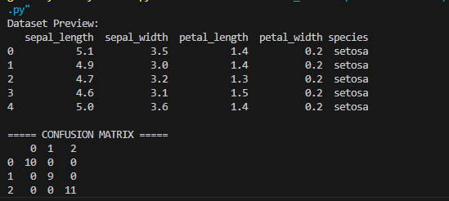

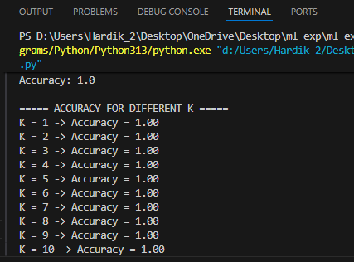

Conclusion:
- KNN successfully classified the dataset based on nearest neighbors.
- The model achieved high accuracy, showing it works well for small datasets.
- Performance depends on the value of K:
  - Small K → high variance (overfitting)
  - Large K → high bias (underfitting)
- Feature scaling significantly improves KNN performance.
- KNN is simple but computationally expensive for large datasets.

